**Coursera Capstone**

**IBM APPLIED DATA SCIENCE**

AN INDIAN RESTAURANT IN

NEW YORK CITY

**By – Shrinath Rajeshirke**

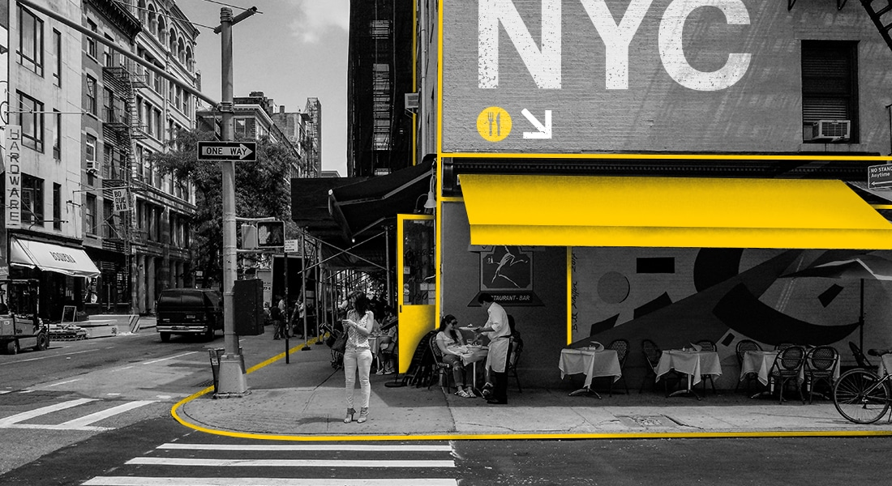

**July 2021**

Introduction

New York is the largest city in the United States with a long history of international immigration. It’s a large and ethnically diverse metropolis. Indians in the New York city metropolitan area constitute one of the largest and fastest growing ethnicities in the New York city metropolitan area of the United States. he New York City region is home to the largest Indian American population among metropolitan areas by a significant margin, enumerating 711,174 uniracial individuals by the 2013–2017 U.S. Census American Community Survey estimates.

This final project explores the best locations for Indian restaurant in the city of New York. So that the owner of the new Indian restaurant can have a great success and consistent profit. In particular, the location of the restaurant is the most important factor for a successful business. So, our project will help investors to find out the best location for starting a Indian restaurant in the New York city.

Business Problem

The main objective of the capstone project is to analyse & select the best location in the city of New York to open a new Indian restaurant. We will use required data science methodologies such as Data Analysis & Data visualization. This project will provide the solutions to answer the business problem of starting a new Indian restaurant in the city. So that the business keep growing in the upcoming years.

Target Audience

This project is useful to investors and developers looking to open an Indian restaurant in the city of New York. Overall, New York is a great place to open a new Indian restaurant. The objective is to recommend the location which neighbourhood of New York city a best choice to start a restaurant.